I am doing a “Survey123” where it has two fields: “Division” and “Select a Map for Reviewing”, which both are
multiple choices. The field “Select a Map for Reviewing” is constrained to the “Division” field choices.
For instance if the user selects Division = Construction, the field “Select a Map for Reviewing” only show images for Construction choice.
Everything works beautifully in Survey123 connect. The problem is when I publish the survey the field “Select a Map for Reviewing” doesn’t work. It doesn’t show any option. See screen shots
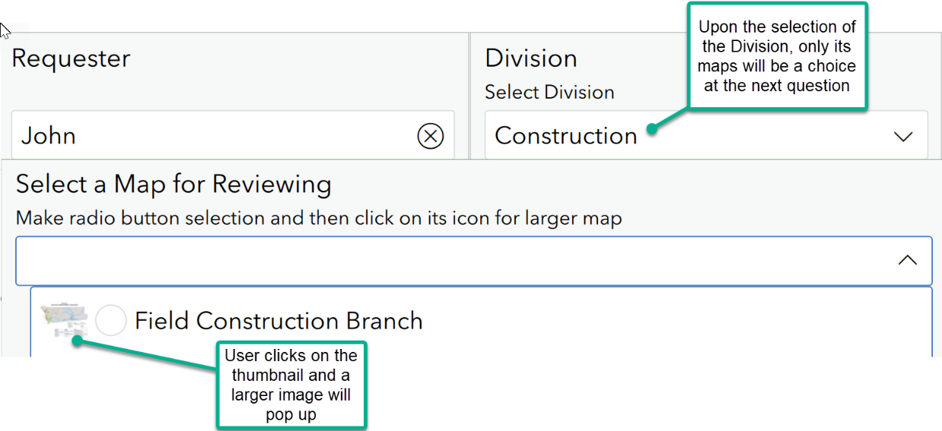

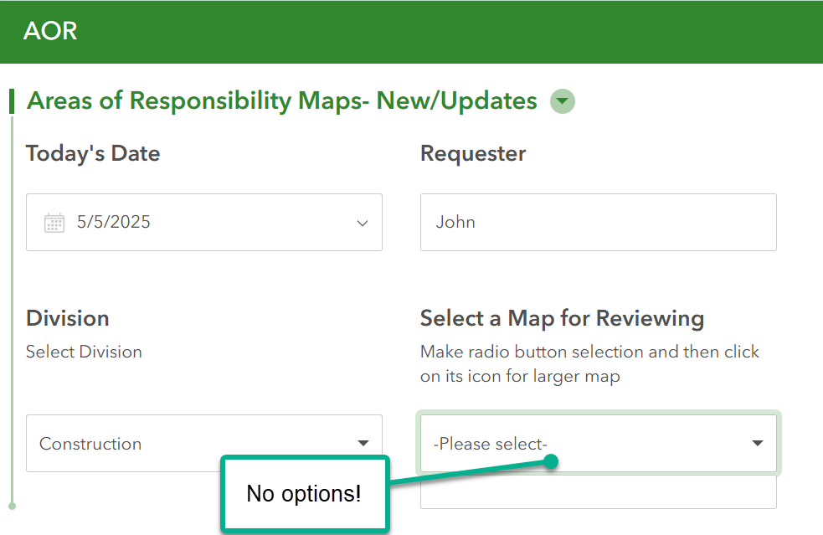

I have ArcGIS Enterprise 10.9 where I am publishing my survey.
Here is a screen shot of the excel file:
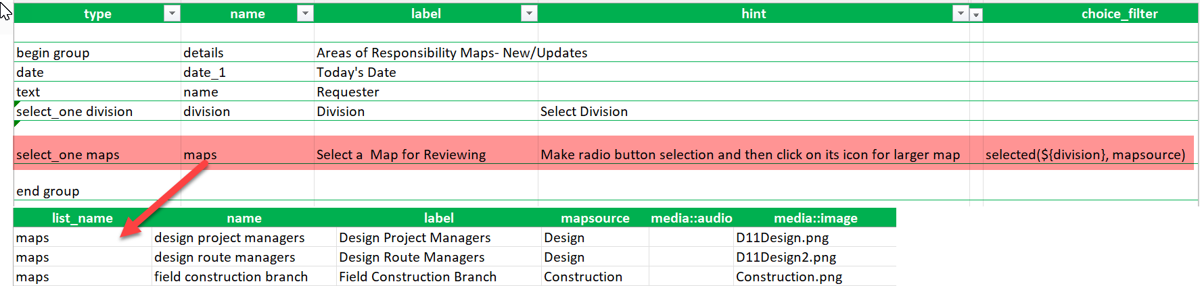

The images are in the folder “media”

