2021 Land Cover – Publishing Image Service

- Bit-depth of source raster should be no more than 8-bit
- Set land cover raster source type property to thematic
- Build raster attribute table and add Red, Green, Blue attributes with desired color values for each land cover class.
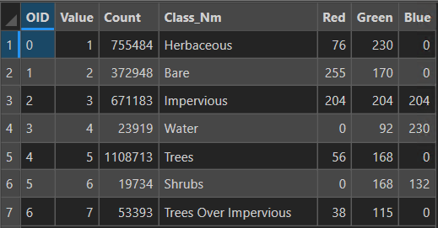
- Build mosaic dataset, set its source type to thematic
- Add raster(s) to mosaic dataset and build overviews. Raster will load in map showing black and white symbology with color ramp min and max values.
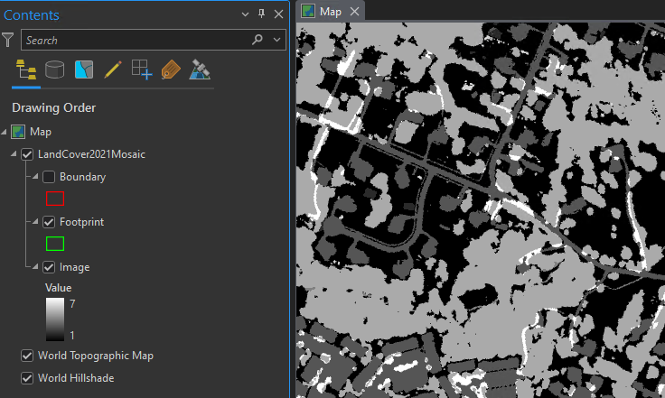
- Open raster functions ArcGIS Pro menu: Imagery>>Raster Functions>>System tab and search for Attribute Table function
- Set properties of Attribute Table function. These can be inherited from a raster file (external option) or built manually (manual option). For 2021, external option was chosen from original raster attribute table.
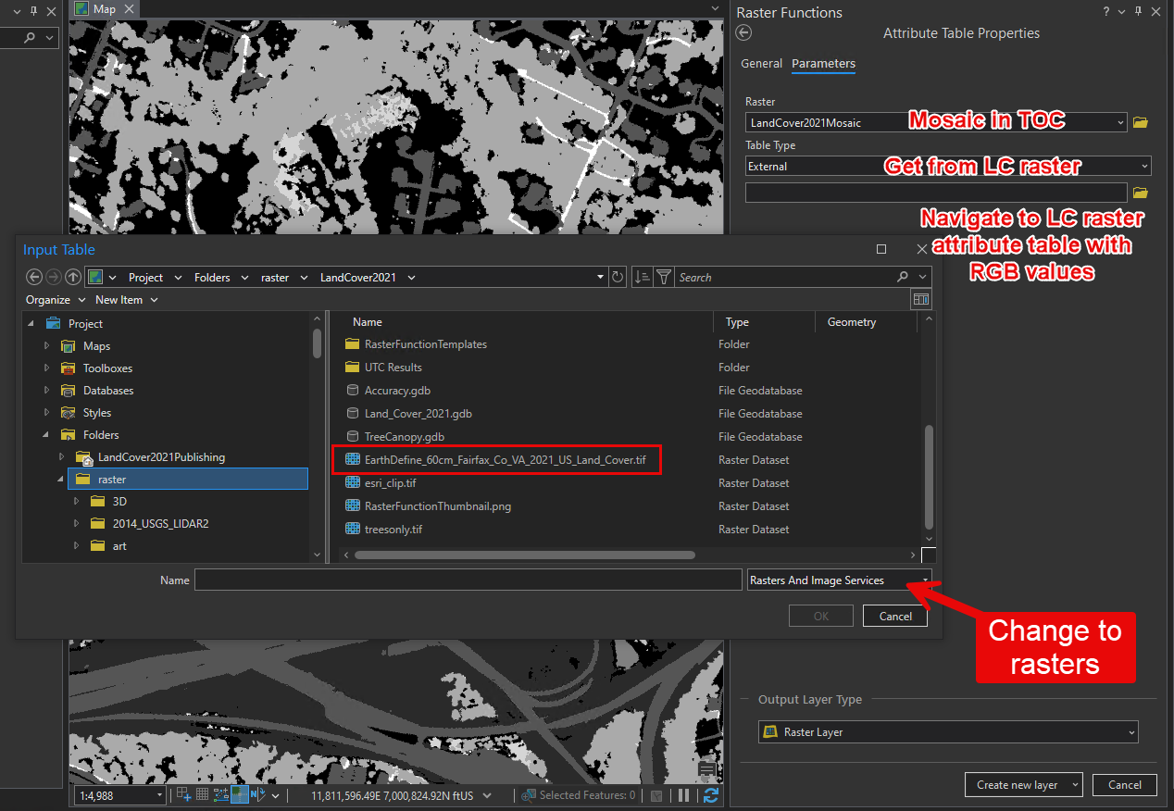
Create new layer will add a symbolized layer to the TOC while Save As will save to the Project or Custom Category. The raster function can be added to the image service from the project category or from a rft.xml file exported from the project.
- For proper resampling in the display of the published image service, choose Nearest Neighbor as the default as this is not inherited from the mosaic dataset.
