I got some problem when i try to export some model to dae.
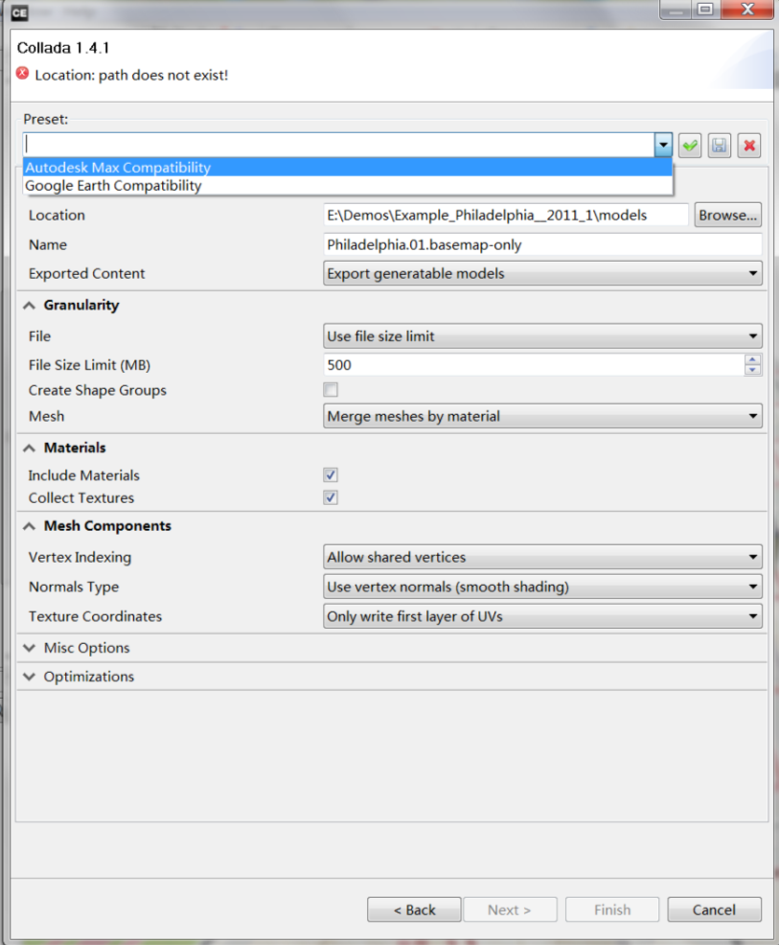
As the picture,i can't find the "ArcGIS compatibility" option.
Also,if i checked the "Include Materials" option,the arcgis will occur an error call "050038" when i try to import the dae to arcgis10.
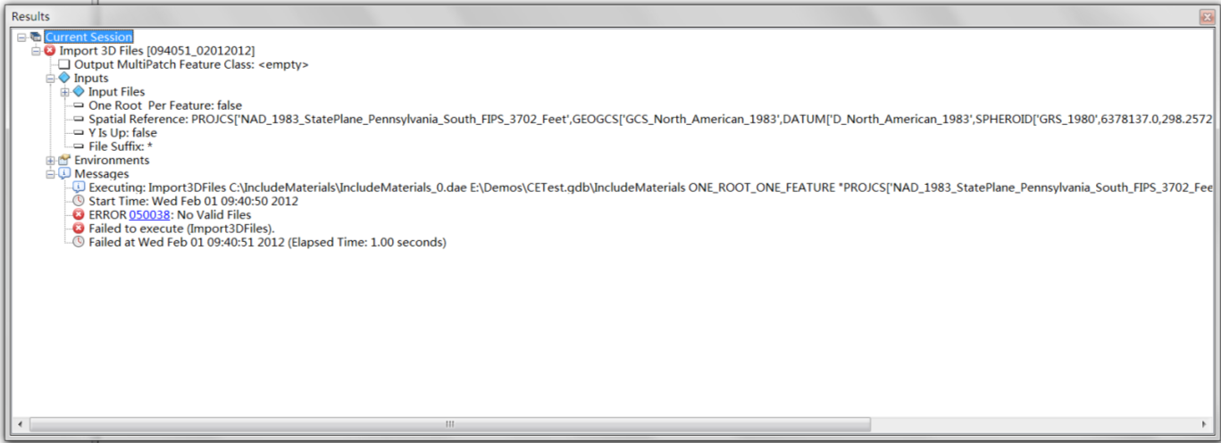
And,if I uncheck the “Include Materials” option,the arcgis can import the model,but the model’s position isn’t correct.
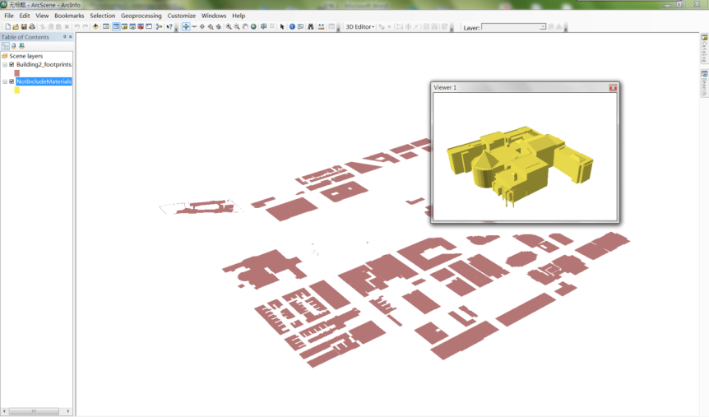
Is there any upgrade for arcgis and cityengine can fix this problem?
My arcgis version: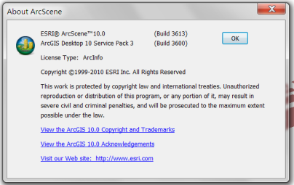
My cityengine version: