Geometry Polygon with ring vértices complete… (AGS service 9.3)
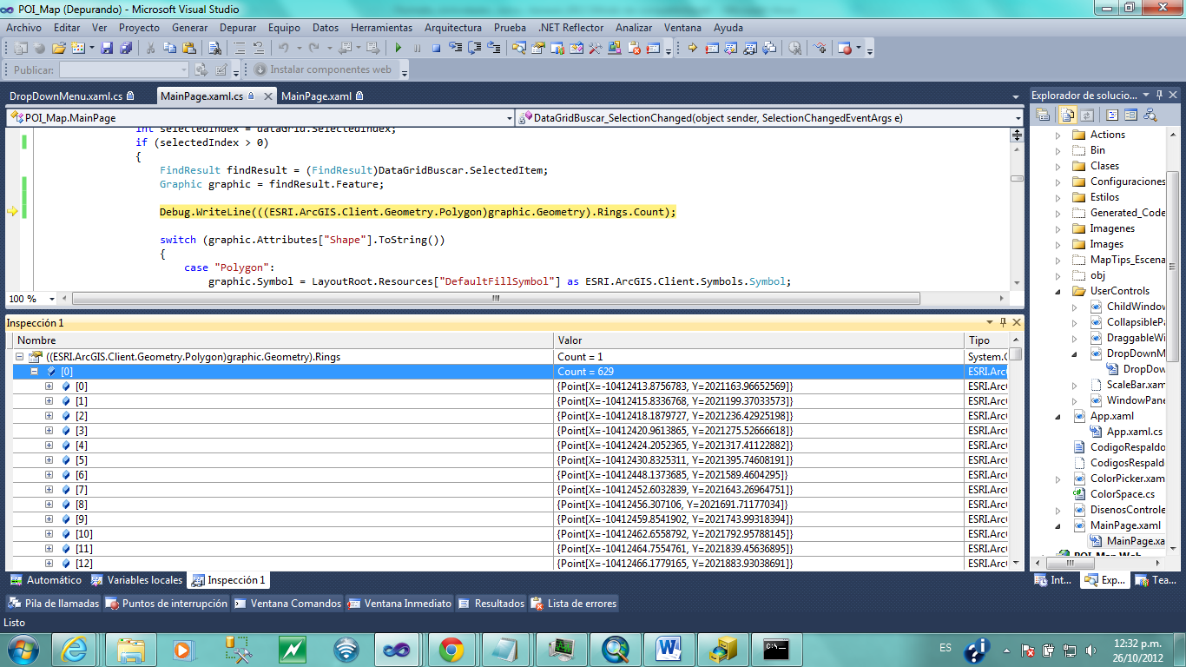

Geometry Polygon with ring vertices incomplete… (AGS Service 10.0)
